

Hello Solidity – Writing First Smart Contract   
  
**Objective/Aim:**



To write, deploy, and test a basic smart contract using Solidity language on Remix IDE.

1. **Apparatus/Software Used:**
2. Laptop/PC
3. Remix IDE (online Solidity compiler)
4. Metamask extension
5. Internet connection

**Theory/Concept:**

1. **Smart Contract:** Self-executing program stored on blockchain.
2. **Solidity**: Main programming language for writing smart contracts on Ethereum.
3. **Remix IDE**: Online tool to write, compile, and deploy Solidity contracts without setup.



**Procedure:**

|  |  |  |  |
| --- | --- | --- | --- |
|  |  |  |  |
|  |  |  |  |
|  |  |  |  |
|  |  |  |  |
|  |  |  |  |
|  |  |  |  |
|  |  |  |  |

1.Open Remix IDE.

2.Create a new solidity file(eg. SimpleStorage.sol)

3.Write a basic SimpleStorage contract.

4.Compile the contract using Solidity compiler version (e.g., ^0.8.0).

5. Deploy contract using Injected provider metamask in Remix.

6.Interact with the contract functions (get message, update message).

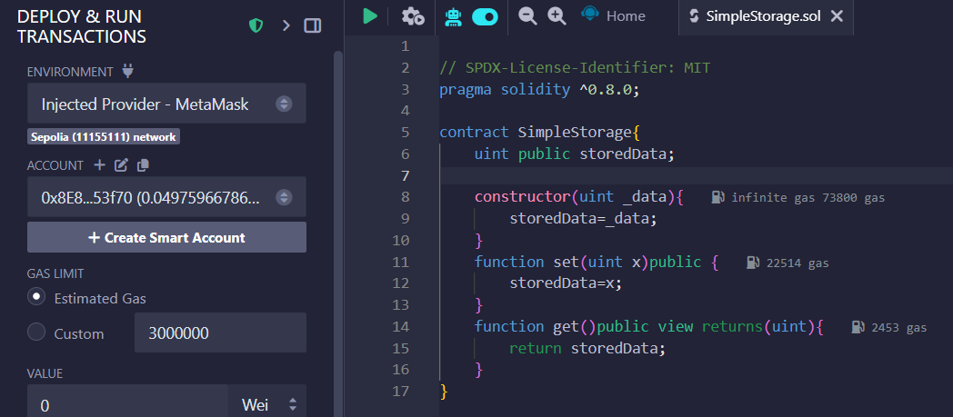

**Observation Table:-**

1. MetaMask wallet connected to Remix IDE successfully.
2. Selected Injected Provider - MetaMask environment in Remix.
3. Chose the correct Ethereum Testnet (Sepolia) in MetaMask.
4. Compiled the smart contract without errors using Remix.
5. Clicked Deploy, MetaMask pop-up appeared for transaction confirmation.
6. Deployment transaction signed and confirmed via MetaMask.
7. Contract deployed successfully on blockchain with a transaction hash.
8. Verified deployed contract and interacted through Remix with MetaMask.
9. Observed gas fees and transaction confirmations in MetaMask.

**ASSESSMENT**

**Signature of the faculty: Signature of the Student:**

**Name:**

**Regn no:**